How to build a junior Developer Portafolio that will get You hired

What does it take ?

Competence

Enthusiasm

Commitment

Humility

Color Combitantion On My Portafolio Black and red or Black ond Pink #FF00A6

Proyects are the most importan thing

Do a connection from my portafolio to my gmail , that persona is seening my portafolio can send me a gmail

In my portafolio I must collocate the certificated of security

Place Social Media Only If they have content related to programming

Create Profiel On GitHub

Create Profiel On Lindelink

Mention project developed in polybag, Paro De Maquina

Paleta de colores en pinterest

Dominio personalisado

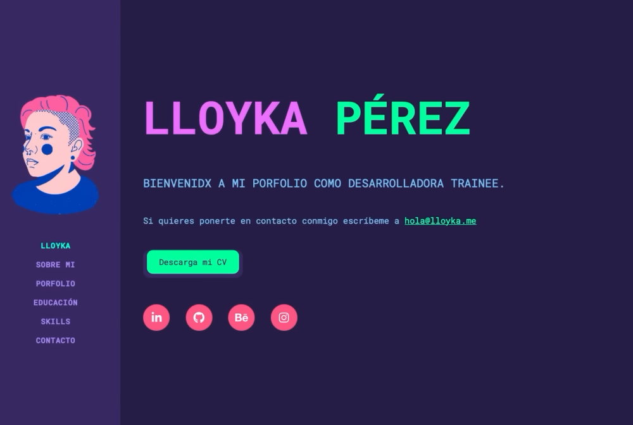

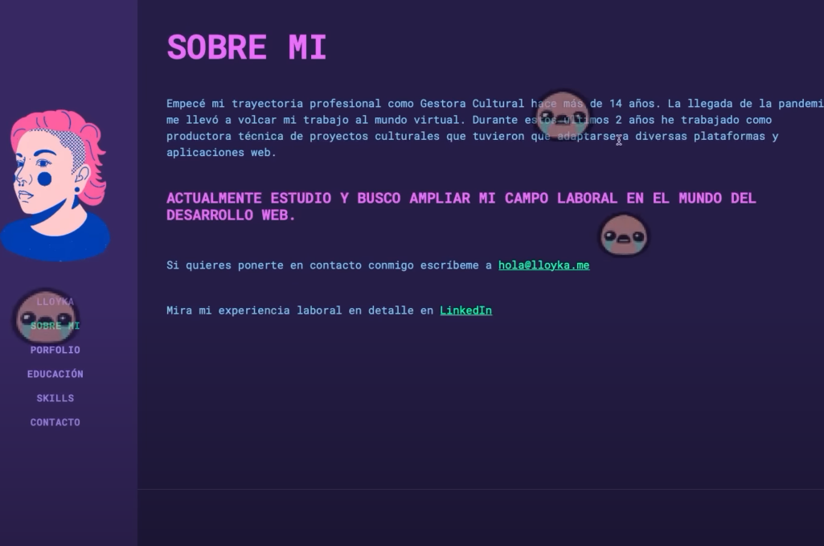

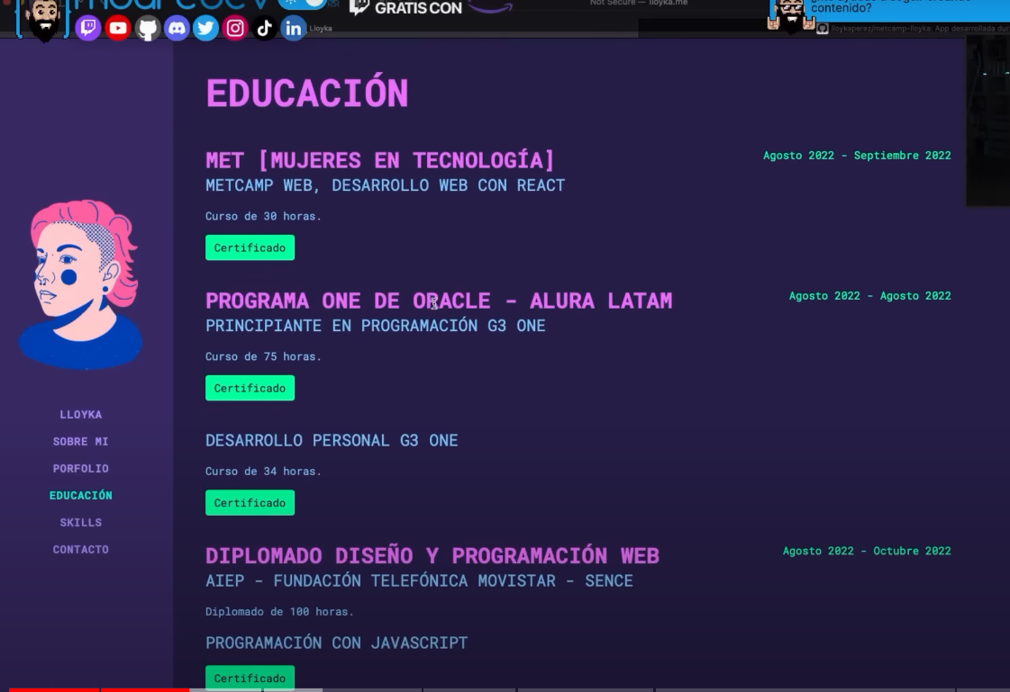

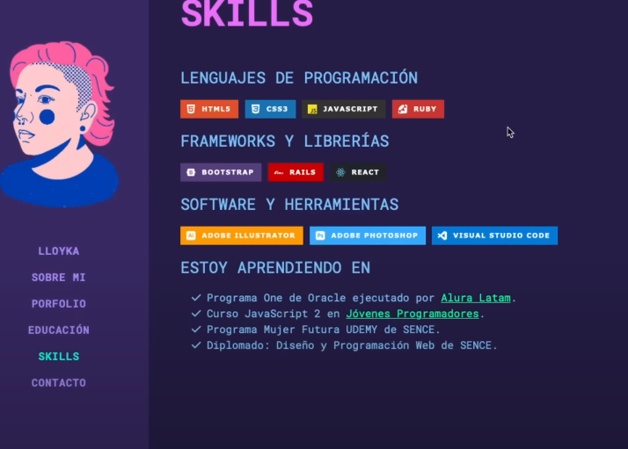

**Colocate btn for download my cv**

**Where Show my proyect , I must divide by lenguaje programming**

**On my portafolio colocate my social media such GitHub , Likeding gmail , intagram , whasap**

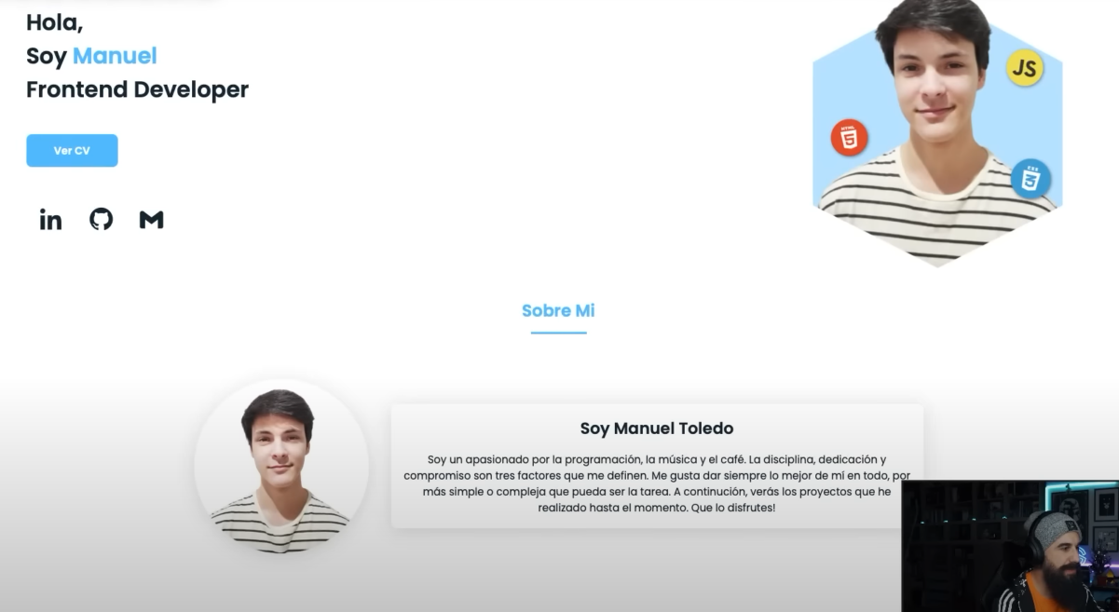

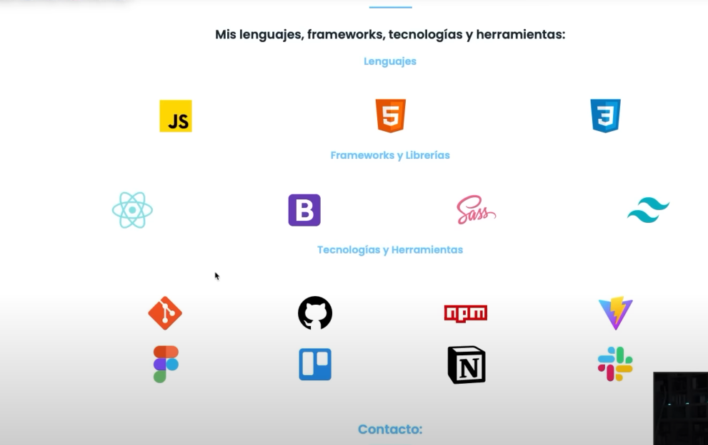

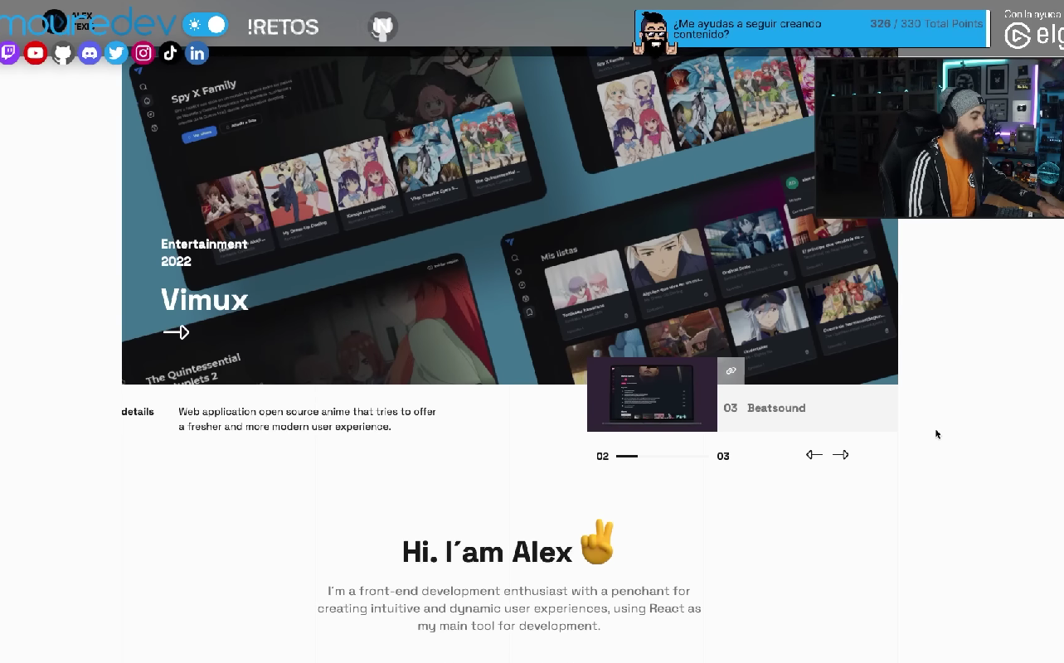

**Slider donde se muestra los proyectos realozadps**

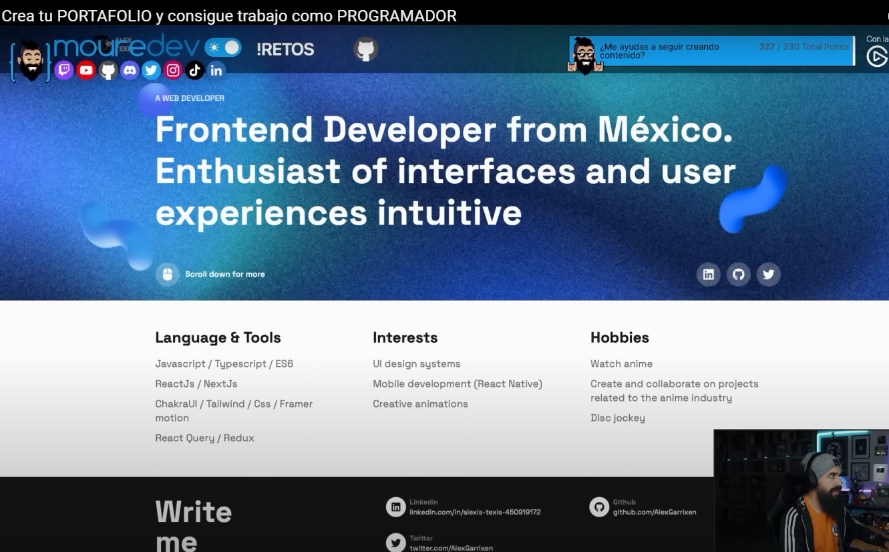

**About me**

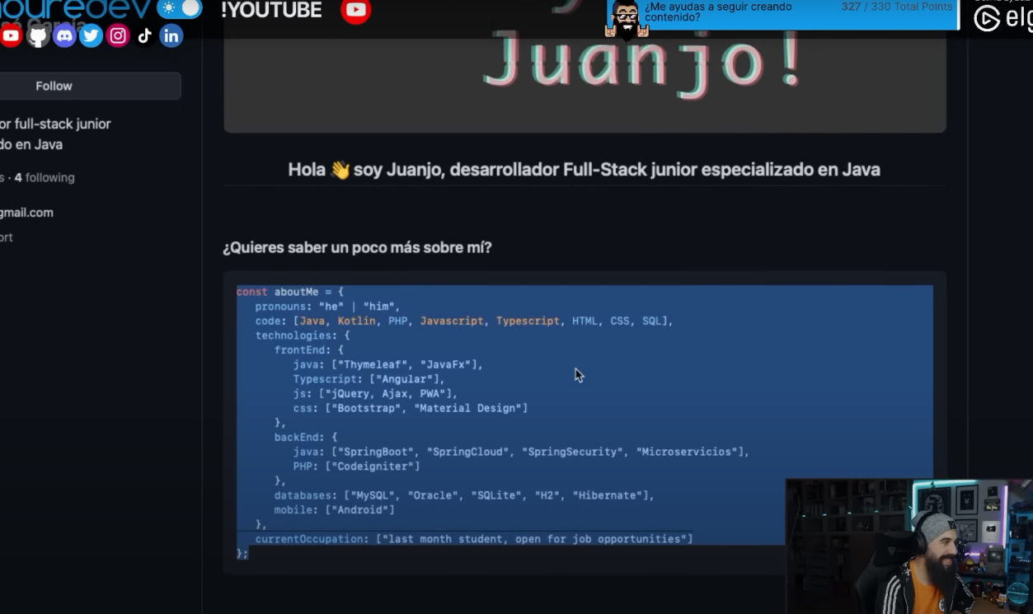

**About me**

